Principal’s Corner
Dear Parents and Caregivers,
Now that spring is officially here and warmer weather is on the way, students will begin outdoor line-up beginning Monday, April 11th. Students may enter the school yard via Hering or Yates Avenue, as well as, the main entrance on Neill Avenue. Please remember that mornings may be a bit cooler; please dress your child accordingly.

Every Tuesday from 2:40-3:20 is set aside for Parent/Teacher engagement. We encourage you to come in and visit your child’s teacher.
Have a wonderful Spring Break!

Sincerely,
Charles Sperrazza
Principal

April Calendar
April 5-6-7 - NYS ELA Exam Grades 3-4-5
April 13-14-15 - NYS Math Exam
Grades 3-4-5
April 25-29 – Spring Break

Graduation Dates
Grade 5: June 24, 2016 at 9:00 at P.S. 108
A separate notice will be sent.

Moving Up Ceremony
Grade K: June 22, 2016 at 9:00
Grade Pre-K: June 23, 2016 at 9:00
A separate notice will be sent.

PTA News
April 11th - Spirit Sale - $1.00
April 19th - Picture Retake Day
April 19th - PTA Meeting 6:30 p.m.

April is Poetry Month
During the month of April, we will be reading/writing poetry in Grades K-5. Please support our work by reading poetry at home with your child…who knows…we may have future poets among us!

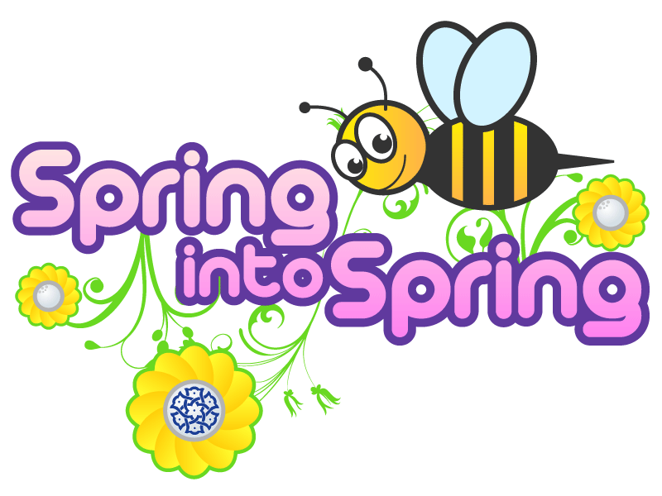

Nurse’s Corner
Pediatric obesity is a growing problem nationally and in NYC, where 43% of our elementary children are overweight or obese. The school is an ideal location to help children and families understand the important balance between energy intake and expenditure. The DOHMH and DOE developed a program called HOP (Healthy Options and Physical Activity in Schools). BMI (Body Mass Index) measures height and weight and the percentile. Having a high or low BMI can lead to health problems, i.e. hypertension, diabetes, etc. At this point we have started assessments and letters will be sent home.

The Open Airways for School is ongoing.

M. Bernas, School Nurse

Parent Coordinator
Happy Spring to all!!!
I hope this finds you well, and hope you all have a wonderful spring. I want to send a special thanks to all the parents who completed the parent survey.
National Volunteer Week is from April 10-16, 2016. I would like to recognize all of our volunteers and thank you all for your time and dedication. You make a difference in our lives every day, Thank You!!
I look forward to seeing more parents sign up to our REMIND APP. I am working on getting more information and resources to all parents on our REMIND APP. If you need guidance on signing up please contact me at 718-863-9829 EXT.1300.
This month is full of workshops and activities for you and your child. For further information on our upcoming events, please visit www.ps108.net.
We greatly appreciate your participation.
Sincerely,
Tabitha Brugman
Parent Coordinator

Important Dates:
April 12 – Storytelling & Bookmaking hosted by Learning Leaders 2:40 -3:20 p.m.
April 19 – Workshop – Special Education Strategies - 2:45 – 3:20 p.m.
April 20 – Movie Pajama Night 5:30-7:00 p.m.
April 21 – NYU Lutheran Dental Examination

